AI LEGAL ADVISOR FOR BASIC LAWS
PROJECT REPORT
Submitted by

ABISHEK R (7376232CB102)
DHARUNKUMAR M (7376232CB115)
PRANAV KARTHICK S K (7376232CB137)
SANJAY M (7376232CB142)

In partial fulfilment for the award of the degree of

BACHELOR OF TECHNOLOGY

in

COMPUTER SCIENCE AND BUSINESS SYSTEMS



BANNARI AMMAN INSTITUTE OF TECHNOLOGY
(An Autonomous Institution Affiliated to Anna University, Chennai)
SATHYAMANGALAM-638401

ANNA UNIVERSITY: CHENNAI 600 025

OCTOBER 2025
BONAFIDE CERTIFICATE

Certified that this project report “AI LEGAL ADVISOR FOR BASIC LAWS” is the Bonafide work of “ABISHEK R (7376232CB102), DHARUNKUMAR M (7376232CB115), PRANAV KARTHICK S K(7376232CB137), and SANJAY M (7376232CB142)” who carried out the project work under my supervision.

Dr. VENKATESAN R | Ms. MOHANAPRIYA K
HEAD OF THE DEPARTMENT | ASSISTANT PROFESSOR
Department of Computer Science and Business Systems | Department of Artificial Intelligence and Machine Learning
Bannari Amman Institute of Technology | Bannari Amman Institute of Technology

Submitted for Project Viva Voce examination held on………………

Internal Examiner I Internal Examiner II

DECLARATION

We affirm that the project work titled “AI Legal Advisor for Basic Laws” being submitted in partial fulfilment for the award of the degree of Bachelor of Technology in Computer Science and Business Systems is the record of original work done by us under the guidance of Ms. Mohanapriya K, Assistant Professor, Department of Artificial Intelligence and Machine Learning. It has not formed a part of any other project work(s) submitted for the award of any degree or diploma, either in this or any other University.

ABISHEK R |  | DHARUNKUMAR M
(7376232CB102) |  | (7376232CB115)

PRANAV KARTHICK S K SANJAY M
(7376232CB137) (7376232CB142)

I certify that the declaration made above by the candidates is true.

Ms. Mohanapriya K

ACKNOWLEDGEMENT

We would like to enunciate heartfelt thanks to our esteemed Chairman Dr. S.V. Balasubramaniam, and the respected Principal Dr. C. Palanisamy for providing excellent facilities and support during the course of study in this institute.
We are grateful to Dr. Venkatesan R, Head of the Department, Department of Computer Science and Business Systems for his valuable suggestions to carry out the project work successfully.
We wish to express our sincere thanks to Ms. Mohanapriya K, Assistant Professor, Department of Artificial Intelligence and Machine Learning, for her constructive ideas, inspirations, encouragement, excellent guidance, and much needed technical support extended to complete our project work.
We would like to thank our friends, faculty and non-teaching staff who have directly and indirectly contributed to the success of this project.

ABISHEK R(7376232CB142)
DHARUNKUMAR M (7376232CB115)
PRANAV KARTHICK S K (7376232CB137)
SANJAY M (7376232CB142)

ABSTRACT

Artificial Intelligence (AI) has transformed access to justice by making complicated legal knowledge more accessible to a larger audience. An artificial intelligence (AI) legal advisor for basic laws is a computer program created to answer legal questions, give general legal understanding, and assist people with basic legal procedures. AI-powered legal aid, in contrast to traditional legal consultation, provides cost-effective solutions, multilingual help, and round-the-clock availability, particularly for those who cannot afford professional legal services. Natural language processing, or NLP, is used by the system to comprehend user enquiries and extract pertinent legal data from statutes, case summaries, and legal provisions.
This AI legal advisor serves as an initial legal aid tool by teaching users about subjects like civil rights, criminal proceedings, consumer complaints, cyber law, and fundamental rights; it does not take the place of a certified advocate. It provides detailed instructions for submitting RTI petitions, consumer disputes, FIRs, and legal notices. Legal restrictions and ethical concerns are essential to such systems in order to guard against abuse and guarantee responsible information dissemination. All things considered, AI legal advisors facilitate access to justice in a quick and easy way, improve legal literacy, and enable people to comprehend their rights.

KEYWORDS: Artificial Intelligence, Legal Advisor, Natural Language Processing,
Access to Justice, Legal Assistance, Legal Literacy, Online Legal Aid, Basic Laws,
Legal Technology, Ethical AI

TABLE OF CONTENT
C.NO | TITLE |  |  | PAGENO.
 | ACKNOWLEDGEMENT |  |  | III
 | ABSTRACT |  |  | 1
 | LIST OF FIGURES |  |  | 4
1 | INTRODUCTION |  |  | 5
 | 1.1 | OVERVIEW OF THE PROJECT |  | 5
 | 1.2 | IMPORTANCE OF THE PROJECT |  | 6
 | 1.3 | OBJECTIVES OF THE PROJECT |  | 7
 | 1.4 | NEED FOR THE PROJECT |  | 7
 | 1.5 | FEATURES OF THE PROJECT |  | 8
 | 1.6 | SCOPE OF THE PROJECT |  | 9
 | 1.7 | ADVANTAGES OF THE PROJECT |  | 10
 | 1.8 | FUTURE EXPANSION |  | 10
2 | LITERATURE SURVEY |  |  | 12
 | 2.1 | EXISTING SYSTEMS |  | 12
 | 2.2 | LIMITATIONS OF EXISTING SYSTEMS |  | 13
 | 2.3 | RELATED RESEARCH WORK |  | 14
 | 2.4 | GAPS IDENTIFIED |  | 15
 | 2.5 | SUMMARY OF FINDINGS |  | 15
3 | OBJECTIVES AND METHODOLOGY |  |  | 17
 | 3.1 | OBJECTIVES OF THE PROPOSED WORK |  | 17
 | 3.2 | PROPOSED METHODOLOGY |  | 18
 |  | 3.2.1 | REQUIREMENTS GATHERING | 18
 |  | 3.2.2 | SYSTEM DESIGN | 18
 |  | 3.2.3 | IMPLEMENTATION | 19
 |  | 3.2.4 | TESTING AND VALIDATION | 19
 | 3.3 | TOOLS AND TECHNOLOGIES |  | 20
 | 3.4 | DATA COLLECTION AND KNOWLEDGE BASE |  | 22
 | 3.5 | SUMMARY |  | 22
4 | PROPOSED WORK MODULES |  |  | 24
 | 4.1 OVERVIEW OF PROPOSED SYSTEM |  |  | 24
 | 4.2 USER INTERFACE MODULE |  |  | 25
 | 4.3 NATURAL LANGUAGE PROCESSING MODULE |  |  | 26
 | 4.4 KNOWLEDGE BASE MODULE |  |  | 27
 | 4.5 AI RESPONSE GENERATION MODULE |  |  | 27
 | 4.6 SECURITY AND PRIVACY MODULE |  |  | 28
 | 4.7 FEEDBACK AND LEARNING MODULE |  |  | 29
 | 4.8 MODULE INTERACTIONS |  |  | 29
 | 4.9 ADVANTAGES OF THE PROPOSED SYSTEM |  |  | 30
5 | RESULTS AND DISCUSSION |  |  | 32
 | 5.1 | OVERVIEW OF EVALUATION PROCESS |  | 32
 | 5.2 | RESULT |  | 32
 | 5.3 | FUNCTIONAL EVALUATION |  | 34
 | 5.4 | USER EVALUATION AND FEEDBACK |  | 35
 | 5.5 | DISCUSSION |  | 36
 | 5.6 | SUMMARY |  | 37
6 | CONCLUSION AND FUTURE ENHANCEMENTS |  |  | 39
 | 6.1 | CONCLUSION |  | 39
 | 6.2 | ACHIEVEMENTS OF THE SYSTEM |  | 40
 | 6.3 | FUTURE ENHANCEMENTS |  | 41
 | 6.4 | FINAL REMARKS |  | 42
7 | REFERENCES |  |  | 44
8 | APPENDICES  8.1 WORK CONTRIBUTION  8.2 PLAGARISM REPORT |  |  | 47  47  50

LIST OF FIGURES
FIGURE NO.  1 | NAME OF THE FIGURE  USECASE DIAGRAM OF THE AI-BASED LEGAL ADVISOR SYSTEM | PAGE NO.  16
2 | OVERVIEW OF AI-BASED LEGAL ADVISOR SYSTEM ARCHITECTURE | 25
3 | FUNCTIONAL FLOW OF THE AI-BASED LEGAL ADVISOR SYSTEM | 31
4 | USER INITIATING A QUERY ABOUT CYBERCRIME REPORTING | 34
5  6 | THE AI ADVISOR GENERATING A RELEVANT AND ACTIONABLE RESPONSE  THE AI CONNECTS WITH THE DIRECT OFFICIAL GOVERNMENT PORTALS | 34  35
7 | A COMPARATIVE ANALYSIS OF THE PROPOSED AI SYSTEM VERSUS TRADITIONAL LEGAL SYSTEMS ON KEY PERFORMANCE METRICS | 38

CHAPTER 1
INTRODUCTION
1.1 OVERVIEW OF THE PROJECT
Redefining how people interact with information systems, artificial intelligence (AI) has become one of the most revolutionary technologies of the contemporary era. Its impact is felt in a variety of sectors, including healthcare, education, finance, law, and transportation. Although technology has advanced, the legal industry is still one of the most complex and least digitalized. The complex nature of legal papers, the volume of legal material, and frequent modifications make it challenging for regular people to comprehend their rights and responsibilities.
The AI-Based Legal Advisor for Basic Laws was created to overcome this difficulty by making legal knowledge more approachable and straightforward. As an intelligent virtual assistant, the technology decodes user inquiries in plain language and produces pertinent legal answers. The platform bridges the gap between layperson comprehension and complicated legal writings by utilizing machine learning (ML), natural language processing (NLP), and artificial intelligence (AI).
Accessibility and user interactivity are key design elements of the system. Rather than needing legal knowledge or manual document navigation, users can submit basic queries and get prompt, pertinent responses. Tenancy rules, consumer protection, property disputes, and constitutional rights are just a few of the issues it offers contextual explanations for. The platform serves as a tool for instruction and advice because of its interactivity.
The project also supports India's e-Government and Digital India programs, which focus on technology-driven services, accountability, and transparency. By developing an AI-powered legal guide, the project supports the national goal of guaranteeing that all citizens have access to legal knowledge, irrespective of their location, financial situation, or level of education. Beyond only being a technical advancement, this initiative represents a social revolution in which technology is used to promote empowerment and equality.
1.2 IMPORTANCE OF THE PROJECT
On the basis of legal knowledge, justice and the rule of law are established. In a democracy, knowing one's legal rights and obligations is essential, not optional. Regretfully, many people are unaware of this, which causes them to be unaware of their rights and available options. This gap is further widened by the lack of easily available and reasonably priced legal consultation.
By making legal knowledge more accessible to all, the AI-Based Legal Advisor is essential to closing this gap. It enables people to act and learn without relying on expensive legal assistance for simple matters. The approach encourages critical comprehension rather than passive dependence by teaching users the rationale behind law provisions in addition to providing prompt responses.
There are several ways to highlight this project's significance:
- Social Dimension: It lessens social injustices brought on by ignorance and improves legal literacy.
- Technological Aspect: It automates legal thinking by combining AI, NLP, and knowledge management.
- Economic Aspect: It lessens the cost of hiring an expert to answer frequent legal questions.
- Educational Aspect: Its user-friendly interface encourages self-learning and awareness.
- Administrative Aspect: It helps public and legal organizations undergo digital change.
When these factors are taken into consideration, the project becomes a tool for social change as well as a technological milestone. It lays out a blueprint for how intelligent systems may advance equity, inclusivity, and openness at the federal level.
1.3 OBJECTIVES OF THE PROJECT
Accessibility, accuracy, and user empowerment are the clear goals of the AI-Based Legal Advisor's design. Ensuring that all users, regardless of their background, may obtain trustworthy legal insights is its main goal.
The specific goals are as follows:
In order to automate the retrieval and summation of validated legal material from structured knowledge bases, a smart legal advisor that can comprehend user inquiries written in natural language must be created.
- To provide a user-friendly, linguistically inclusive, and intuitive interface.
- To use models based on natural language processing (NLP) that comprehend legal context and provide precise interpretations.
- Real-time data updates and feedback analysis are used to guarantee ongoing system learning.
- To safeguard data privacy through safe transmission techniques and secure storage;
- To raise awareness of routine legal processes and citizen rights;
- To support the broader movement toward accessible justice and digital government.
By improving confidence, transparency, and literacy in the legal system, these goals guarantee that the project not only functions well as a technological product but also adds value to society.
1.4 NEED FOR THE PROJECT
Every element of daily life is impacted by the laws, rules, and regulations that increasingly regulate modern civilization. The vast majority of people, however, are not aware of their legal rights and responsibilities. Because of this ignorance, people frequently make poor or delayed decisions and are left open to abuse.
In many developing nations, access to justice is hampered by the scarcity of legal experts and the high expense of consultation. Even when information may be found online, it is frequently dispersed, erratic, or expressed in technical language. Only a small portion of the population is able to accurately read legal materials, leading to a digital divide.
The AI-Based Legal Advisor fulfills a critical need by transforming static legal data into interactive and understandable content. It reduces the dependency on legal professionals for preliminary consultations and empowers individuals to take timely and informed action. By offering 24/7 availability and multilingual support, it ensures inclusivity and convenience for users across different demographics.
Furthermore, the system supports educational institutions, NGOs, and awareness campaigns by serving as a ready reference tool for basic legal understanding. It ultimately strengthens democratic participation by ensuring that citizens are well-informed and confident in exercising their rights.
1.5 FEATURES OF THE PROJECT
Numerous integrated elements in the AI-Based Legal Advisor guarantee accuracy, flexibility, and operational efficiency.
The following are important features:
A smooth question-and-answer exchange in plain language is made possible via the User Interaction Module. In order to give pertinent information, the AI engine uses machine-learning algorithms to process inquiries.
- Knowledge Base: Holds statutes, new and updated legal papers, and frequently asked questions.
- NLP Integration: Recognizes linguistic subtleties to decipher user inquiries.
- Security Framework: Uses encryption to safeguard user data and preserve confidentiality.
- Feedback Mechanism: Gathers user feedback to enhance and improve system precision.
- Scalability: The educational mode allows students and scholars to study legal ideas in an organized manner.
With the help of these capabilities, the system transcends the role of a chatbot and turns into a comprehensive knowledge-driven legal aid platform that grows and changes with each exchange.
1.6 SCOPE OF THE PROJECT
Several legal domains and user segments are covered by the project's scope. General inquiries about labour laws, consumer protection, family law, criminal law, and civil law are intended to be addressed by the AI-Based Legal Advisor. It can help people, businesses, and institutions that want basic legal clarification before hiring legal assistance.The initiative serves as a tool for public education in addition to being a platform for query response. It can be utilized in educational institutions, community awareness campaigns, and schools to help younger generations learn about the law. Because the system is modular, it can grow either horizontally—by adding other issues like property, taxation, or cyber laws—or vertically—by adding deeper insights inside a single legal domain.
The system has the potential to develop into a national digital legal ecosystem in the future, helping people with online complaint filing, basic legal document preparation, and court procedural comprehension. This scalability guarantees that the system will continue to be flexible, sustainable, and in line with upcoming developments in both technology and the law.
1.7 ADVANTAGES OF THE PROJECT
Using an AI-based legal advisor has the following advantages:
- It saves time and effort by providing instant answers, unlike manual searches.
- It saves money by doing away with consultation costs for straightforward problems.
- By using current and validated legal data, it guarantees dependability.
- It ensures user privacy and increases public confidence in digital platforms.
- It facilitates multilingual communication, improving inclusivity.
- By encouraging digital citizenship, it fortifies the bond between technology and governance.
- When taken as a whole, these benefits position the project as a trailblazing move in using AI into public legal services and education.
1.8 FUTURE EXPANSION
Opportunities for technological innovation and societal impact abound in this project's future. As AI develops further, a number of improvements can be made to increase usefulness and boost efficiency. Potential future enhancements could involve:
- Connecting to real-time databases to receive automated updates on new legislation and changes.
- The use of cutting-edge speech and voice recognition technology to enable hands-free access.
- To guarantee nationwide inclusivity, regional language support has been included.
- Development of specialized fields like intellectual property, cyber, or environmental law.
- The creation of a mobile version to make it accessible on smartphones.
- Analysis of likely outcomes of legal scenarios using AI prediction models.
- Assistance with outreach and validation through partnerships with educational institutions, NGOs, and legal firms.
By integrating these developments, the system can mature from a basic legal information assistant into a fully functional digital legal infrastructure that supports justice, awareness, and transparency in every aspect of civic life.
CHAPTER 2
LITERATURE SURVEY
2.1 EXISTING SYSTEMS
In the last ten years, an increasing number of digital platforms have tried to automate certain aspects of the legal process by using artificial intelligence to distribute information, generate documents, or predict cases. The majority of these initiatives are restricted in terms of accessibility, region, or scope, despite the fact that they show the promise of AI in law.
In contrast to common individuals, several international systems were designed for lawyers, courts, or research specialists. Although Do Not Pay, ROSS Intelligence, Law Bot, and Legal Robot were examples of early attempts to connect technology and law, their flaws prevented widespread acceptance. Do Not Pay, for example, mostly used static rule-based reasoning but automated certain operations like appealing parking tickets or cancelling memberships. Although ROSS Intelligence used natural language search for legal research, its price and design limited its use to professional settings. Likewise, while Law Bot showed academic competence in answering legal questions, it lacked multilingual capabilities and comprehensive coverage.
A few regional projects have surfaced in underdeveloped nations beyond these, but the majority rely significantly on human review or manual data entry, which limits scalability. Without providing comprehensive, publicly-oriented advice, most of these platforms concentrate on certain areas, such as contracts, compliance verification, or customer complaints.
As a result, even with significant advancements, there is currently no one platform that offers free, multilingual, AI-driven legal aid that is both advisory and instructive. The lack of a system like this amply illustrates the potential of the AI-Based Legal Advisor for Basic Laws, which combines automation, accessibility, and awareness in a novel way.

2.2 LIMITATIONS OF EXISTING SYSTEMS
The limitations of current legal technology solutions are similar and prevent their widespread use.
Lack of Accessibility: The majority of the tools that are available are designed for legal professionals rather than the general public. First-time users are discouraged by their interfaces, which presume knowledge of legal terminology and procedures.

High Cost and Subscription Models: Professional legal research engines and databases have costly subscription plans. Access for students, non-governmental organizations, and regular people in need of basic direction is restricted by this cost barrier.

Language Barriers: English is the sole language used by most programs. This limits inclusion and keeps non-English speakers from gaining anything in multilingual society.

Knowledge bases that are static: Rule-based systems need to be manually updated anytime laws change. Such inflexibility impairs accuracy and slows the incorporation of modifications or new court rulings.

Ethical and Privacy Issues: A number of online legal assistants send user information to other servers without clear privacy guidelines. This calls into question trust and confidentiality.

Restricted Scope and Context Understanding: The majority of chatbots are only able to respond to pre-formulated or keyword-based questions. They provide insufficient responses because they are unable to understand contextual links or complex follow-up queries.
In conclusion, modern legal systems are not adaptable, multilingual, or capable of adaptive learning. These shortcomings provide a compelling case for creating a scalable, safe, and people-focused next-generation AI advisor.
2.3 RELATED RESEARCH WORK
Over the past few years, scholarly investigation into the use of AI in the legal domain has significantly increased. For legal reasoning, machine learning, text mining, and natural language comprehension have all been the subject of numerous studies.
Using tokenization and entity recognition, early research like Legal Information Retrieval Using NLP (2018) showed how algorithms could locate statutory references and extract important sections from lengthy documents. In order to demonstrate the potential and constraints of keyword-based systems, a prototype chatbot using Python's NLTK library was developed for AI in Legal Assistance – A Chatbot Approach (2019).
To replicate legal arguments, later initiatives like as the Intelligent Legal Reasoning System (2020) used deep learning networks and ontology-based reasoning. These methods, while technically sophisticated, limited accessibility because to their high processing demands and legal dataset curation requirements.
Legal Text Summarization Using BERT (2021) is an example of how recent developments in transformer designs have made it possible to automatically summarize acts and decisions, significantly lowering the amount of human labor required. In 2022, the AI-Powered Justice Delivery System looked into predictive analytics for court decision-support, showing how machine intelligence could help clerks and judges by pointing out patterns in previous cases.
Although every study offers insightful information, the majority focus on institutional or professional use cases. The lack of free access, citizen-centric design, and user-friendly interfaces is a recurring issue in literature. The originality and social importance of a platform devoted to general legal awareness rather than courtroom analytics are highlighted by these gaps.

2.4 GAPS IDENTIFIED
From the examination of existing tools and academic work, several critical gaps emerge:
● Target Audience Misalignment: Most AI-driven legal systems are designed for practitioners and researchers, not the layperson.
● Insufficient Focus on Awareness: Few systems attempt to teach or explain basic laws in simple terms.
● Limited Multilingual Support: Regional and vernacular language integration is often neglected.
● Lack of Adaptive Learning: Rule-based architectures cannot learn from user interactions or evolving statutes.
● Data Privacy Deficiencies: Transparent handling of user data is rarely prioritized, deterring public trust.
● Narrow Legal Coverage: Existing models handle specialized domains instead of general civic laws.
● Technical Complexity: Many research systems require high computational resources, making them impractical for public deployment.
By using scalable AI models, multilingual natural language processing, and secure data practices to build an ecosystem focused on citizens, the proposed AI-Based Legal Advisor for Basic Laws directly tackles these constraints. The fear of technical legal jargon is eliminated by its natural-language interface, and its adaptive knowledge base guarantees ongoing relevance.
2.5 SUMMARY OF FINDINGS
Even though AI applications in law have developed quickly, the benefits are still mostly felt inside professional circles, according to the literature assessment. There are very few systems that concentrate on everyday help and broad legal literacy.

The main conclusions can be summed up as follows: An intelligent, citizen-friendly legal platform can greatly enhance social awareness and empowerment.
● The global trend in AI-legal research places more emphasis on automating legal research and document analysis than on public education.
● Current systems lack linguistic diversity, accessibility, and affordability.
● Ethical AI and privacy-driven architectures are essential for building user trust in digital legal services.
● Future studies should concentrate on developing solutions that combine practical usability with educational value.
The AI-Based Legal Advisor for Basic Laws thus distinguishes itself as a singular contribution that blends cutting-edge computer techniques with public service goals. It goes beyond automation to achieve a social and educational goal of democratizing access to clear, intelligible, and transparent legal knowledge.
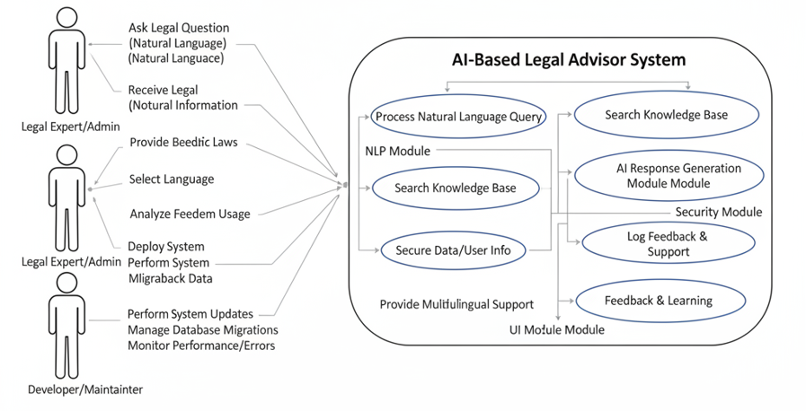
Figure 1: Use case diagram of the AI-Based Legal Advisor System

CHAPTER 3
OBJECTIVES AND METHODOLOGY
3.1 OBJECTIVES OF THE PROPOSED WORK
Designing and implementing an AI-based legal advisor that can give citizens accurate, comprehensible, and trustworthy legal information is the main goal of this project. For common concerns, the approach is meant to facilitate decision-making without the need for expert legal advice, empower people with awareness of their rights, and make it easier to grasp legal frameworks. The project combines cutting-edge AI and NLP methods with contemporary web technologies to accomplish this, guaranteeing performance and accessibility. The particular goals are as follows:
- The goal is to create an AI-powered legal advisor that is user-centric and can comprehend and reply to natural language inquiries.
- Additionally, an intelligent knowledge base that contains verified laws, acts, and updates from reputable sources will be built.
- Supporting multilingual interaction would make it easier for people with different linguistic backgrounds to access information.
- For context-aware query comprehension and pertinent answer production, AI and NLP will be used.
- To make sure that the user and the system communicate in a private and secure manner.
- Incorporating adaptive learning will enable the system to continue improve through updated datasets and user feedback.
- The objective is to develop a modular, responsive architecture that can be implemented in both web and mobile settings.
- To support digital inclusiveness and public legal literacy while supporting e-Government and Digital India activities.
These objectives collectively ensure that the proposed system is not only a technological innovation but also a socially beneficial platform that enhances justice awareness and legal empowerment among citizens.
3.2 PROPOSED METHODOLOGY
The AI-Based Legal Advisor's methodology integrates phases of research, system design, implementation, and testing. Every stage helps to build a legal advice platform that is safe, dependable, and expandable. Maintainability, performance efficiency, and functional accuracy are guaranteed by the methodical framework of the approach.There are various crucial phases in the development process:
3.2.1 REQUIREMENTS GATHERING
Technical viability and user needs are the main objectives of the first stage.
- Feedback forms and surveys are used to find out what obstacles citizens face when trying to obtain legal information.
- Functional and non-functional requirements, such as performance goals, data security standards, and response time constraints, are defined.
- Legal experts and documentation are consulted to establish domain-specific guidelines for system training and testing.
- Existing AI-based systems are examined to assess limitations in usability, accuracy, and affordability.
- This stage guarantees that the design is sustainable and technically possible while taking into account actual legal requirements.
3.2.2 SYSTEM DESIGN
The system's processing, data management, and user interface levels are divided by its modular architecture.
- Users may naturally enter queries and receive readable results because to the frontend's accessibility and usability design.
- The backend manages secure module communication, logic processing, and NLP interpretation.
- A knowledge base is built to organize laws, regulations, and acts and index them for quick retrieval.
- Data flow diagrams and architecture models are produced to ensure smooth interaction among components, and the system design integrates multilingual assistance to encourage inclusion across linguistic regions.
The modular design facilitates future scaling, making it simple to incorporate new features like chat history, document automation, and real-time legal updates.
3.2.3 IMPLEMENTATION
Using web technologies and AI models, the design is transformed into a functional system during this phase. Developing the user interface with contemporary frameworks for accessibility and responsiveness is part of the implementation.AI and NLP modules that can accurately process natural language queries are integrated. Developing safe methods for processing data so that users can communicate and provide feedback. Setting up the system in a web environment that facilitates dependability and scalability. Software engineering principles are followed and clean, maintainable code is used to implement each component.
3.2.4 TESTING AND VALIDATION
To make sure it works as intended, the system is put through extensive testing after implementation.
- Unit testing confirms the proper operation of individual parts, like the query processor and NLP parser.
- Integration testing guarantees smooth connection between various modules, including the database, AI engine, and user interface.
- Performance testing verifies the system's stability and speed under various user inquiries.
- To verify that the answers are correct, pertinent, and intelligible, validation testing uses real-world situations.
- To gauge test participants' pleasure, usability, and answer clarity, user acceptability testing gathers their input.
Before the system is finally deployed, any problems found are fixed to guarantee that it satisfies all functional and non-functional requirements.
3.3 TOOLS AND TECHNOLOGIES
The AI-Based Legal Advisor employs a combination of advanced frontend, backend, and development technologies that enable efficient, secure, and high-performance operation. These tools were carefully selected to ensure scalability, maintainability, and ease of deployment.
Frontend:
The frontend forms the interactive layer of the system and is designed for speed, responsiveness, and accessibility.
- React 18 (react, react-dom): Framework for building dynamic and component-based user interfaces.
- Vite: A fast bundler and development environment using @vitejs/plugin-react.
- TypeScript: Provides strong typing and scalability for React components.
- Tailwind CSS: Utility-first styling framework with @tailwindcss/typography, tailwind-merge, and tailwindcss-animate for consistent design.
- Radix UI: Component library (@radix-ui/react-*) for accessible UI primitives.
- Lucide React: Icon set integration for a clean visual experience.
- Framer Motion: Used for smooth animations and interactive transitions.
- Recharts: Handles graphical visualizations like charts and data summaries.
- Embla Carousel, React Icons, Wouter: Libraries for carousel sliders, icons, and client-side routing.
Backend:
The backend provides the logical and data-handling capabilities of the system.
- Express.js: Lightweight Node.js framework used to build the RESTful API.
- Express-session + Passport.js: Used for authentication and session management (local strategy).
- Multer: Enables secure handling of file uploads.
- WebSockets (ws): Facilitates real-time communication between the client and server.
- Drizzle ORM: Type-safe Object Relational Mapping tool (drizzle-orm, drizzle-zod, drizzle-kit) for managing PostgreSQL databases.
- PostgreSQL: Primary database accessed via @neondatabase/serverless, connect-pg-simple, and memorystore for scalable session storage.
Development and Build Tools:
To streamline deployment, testing, and maintenance, several tools and configurations are used:
- Vite: For frontend bundling.
- esbuild: For backend bundling and optimization.
- tsx: For running TypeScript files during development.
- PostCSS + Autoprefixer: For CSS processing and browser compatibility.
- Drizzle-kit: For database migrations.
- Type Definitions: Libraries like @types/node and @types/express ensure proper typing across the codebase.
Development Commands:
- npm run dev → Runs Express server and frontend concurrently in development mode.
- npm run build → Builds frontend and bundles backend using esbuild.
- npm run start → Launches production server (node dist/index.js).
- npm run db:push → Executes database migrations with Drizzle.
This combination of technologies provides a robust environment for building scalable AI applications that are secure, fast, and user-friendly.
3.4 DATA COLLECTION AND KNOWLEDGE BASE
The precision and organization of the system's data have a significant impact on how well it responds. Reliable legal advice is ensured by a knowledge base that is meticulously selected and regularly updated. Verified government sources, legal databases, and official acts are the sources of legal data. Texts are pre-processed using natural language processing (NLP) techniques like tokenization, stemming, and the removal of irrelevant information. The cleaned data is categorized by domain (e.g., consumer law, labour law, and property law) and indexed for efficient retrieval. The system uses vector-based search for semantic matching, which allows the AI to comprehend context rather than just keywords. Updates are made on a regular basis to reflect new amendments or court decisions.
3.5 SUMMARY
This chapter described the AI-Based Legal Advisor's goals, development process, and technical underpinnings. The procedure ensures correctness and accessibility by fusing contemporary web construction tools with AI-driven reasoning.
A secure, intelligent, and scalable legal advisory system is the end result of the project's methodical requirement collecting, modular design, reliable implementation, and extensive testing. Advanced technologies like React, Express, and PostgreSQL are integrated to provide excellent performance and maintainability, while the AI and NLP components guarantee responses that are relevant and contextually aware.
In general, the approach offers a thorough framework for turning legal data into an effective, interactive tool that promotes digital transformation in the legal industry and raises public legal literacy.
CHAPTER 4
PROPOSED WORK MODULES
4.1 OVERVIEW OF PROPOSED SYSTEM
A modular system, the proposed AI-Based Legal Advisor is intended to provide users with quick, precise, and context-aware legal information. It combines the power of natural language processing (NLP), artificial intelligence, and a vast body of legal knowledge to comprehend inquiries and deliver trustworthy answers. The modular design guarantees that every part fulfills a specific purpose while preserving smooth interaction with the others. Scalability, fault isolation, and simpler maintenance are all supported by this separation of functions. Thus, the system doesn't need to be completely redesigned in order to be expanded or changed.
The main objective of the suggested architecture is to simplify legal jargon so that average people may understand it. The AI can interpret user-inputted plaintext questions in three stages: comprehending the query, retrieving information, and creating a response. Additionally, the modular design guarantees system stability, effective data flow, and flexibility for upcoming improvements like multilingual expansion and AI-powered personalization. Briefly mention it as a key feature that enhances the system's utility beyond mere legal advice, positioning it as a holistic civic resource.
The system's main functional modules are as follows:
- User Interface Module
- Natural Language Processing Module
- Knowledge Base Module
- AI Response Generation Module
- Security and Privacy Module
- Feedback and Learning Module
Each module contributes toward the overarching goal of democratizing access to legal knowledge by providing intuitive, fast, and accurate assistance.
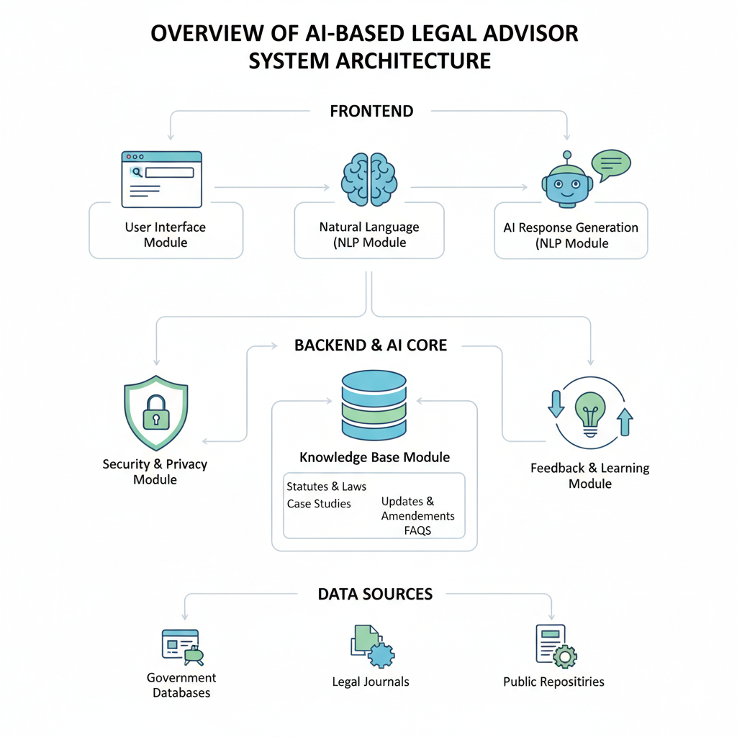
Figure 2: Overview of AI-Based Legal Advisor System Architecture
4.2 USER INTERFACE MODULE
Between the system and its users, the User Interface (UI) Module acts as a communication link. It offers an easy-to-use interface where users may enter legal queries in natural language and get readable, understandable responses.
Because of its accessibility-focused design, users can navigate it without any prior technical or legal knowledge. The platform is user-friendly for users from a variety of backgrounds thanks to features like language selection options, easy text boxes, and flexible layout.
Additionally, this module is in charge of displaying responses that are well-organized and structured. Headings, important topics, and optional references for additional reading are all included in the plainly given information. Additionally, the user interface integrates accessibility guidelines including scalable fonts and flexible color schemes to accommodate all users, including those with visual impairments.
Users can score the responses' usefulness and clarity using an integrated feedback area in the interface. The learning module receives this feedback automatically and uses it to improve the AI's performance going forward. Thus, in addition to being a display element, the user interface (UI) is a hub for dynamic interaction that changes according to human activity.
This is a crucial section. Explain how these links and emergency numbers will be presented clearly and accessibly within the UI.You could describe a dedicated "Government Services" or "Action & Help" section in the interface.Detail how the emergency contacts will be prominently displayed for quick access.Mention the intuitive design that allows users to easily find and click on these links.
4.3 NATURAL LANGUAGE PROCESSING MODULE
The system's Natural Language Processing (NLP) Module is one of its most important parts. Unstructured user inquiries are transformed into a structured manner that the AI model can understand. Semantic analysis, tokenization, lemmatization, stop-word elimination, and part-of-speech tagging are some of the sub-steps in this process. The system can comprehend the literal and contextual meaning of user queries thanks to the NLP engine. It may process statements, phrases, or direct queries as inputs. Semantic understanding is how the module makes sure the AI can distinguish between similar terms used in various legal settings.
Maintaining conversational context across numerous user interactions is one of this module's primary features. When a user poses follow-up inquiries about a previous query, the system remembers the relevant details to provide a logical response. This module turns the legal consultation process into an intelligent, context-aware conversation rather than a static text exchange by utilizing sophisticated linguistic models and trained datasets.

4.4 KNOWLEDGE BASE MODULE
The foundation of the AI-Based Legal Advisor is the Knowledge Base Module. It contains organized and authenticated legal data sourced from reputable sources like laws, court rulings, and legal periodicals. Categorization, tagging, and indexing strategies are used to arrange the information, guaranteeing effective data retrieval throughout the AI response process. Users can access the knowledge base in their preferred language thanks to its support for multilingual content.
New laws, revisions, and pertinent case summaries are incorporated through periodic updates. The updating procedure guarantees that users always get the most up-to-date and correct information.
The architecture of this module includes:
● Data Storage Layer: Maintains legal data in structured form.
● Indexing System: Enables fast search and retrieval of relevant records.
● Semantic Linking: Establishes relationships between similar or related laws for broader query interpretation.
While not directly storing legal text, the links themselves are valuable pieces of information. You could mention that the knowledge base will also securely store and manage the URLs and contact numbers, ensuring they are always up-to-date. By combining accuracy, reliability, and scalability, the Knowledge Base Module ensures that the AI generates consistent, factually correct, and contextually relevant responses for all users.
4.5 AI RESPONSE GENERATION MODULE
The system's intelligent decision-maker is the AI Response Generation Module. It extracts relevant information from the knowledge base and processes structured data that is received from the NLP module. After that, the machine-learning model creates responses that are understandable, context-sensitive, and unambiguous. Three crucial steps are involved in the response generation process:
- Query Interpretation: The AI model identifies the intent and domain of the query.
- Information Extraction: Relevant data is fetched from the knowledge base.
- Response Composition: The system constructs a human-like, grammatically coherent answer.
One of this module's distinguishing characteristics is continuous improvement. The AI improves the clarity and relevancy of its answers by using user feedback and system analytics. This self-learning technique enhances the system's accuracy and flexibility over time. The AI Response Module also makes sure that information is presented in an organized way, beginning with broad explanations and, if required, focusing on particular legal clauses or parts. This gives people a more thorough and comprehensive grasp of the subject.
4.6 SECURITY AND PRIVACY MODULE
Any system that handles user data must prioritize security and privacy, especially in the legal sector. All user-server data exchanges are encrypted using safe protocols thanks to the Security and Privacy Module. To provide secrecy, this module uses methods including access restriction, authentication, and data anonymization. No personal identifiers are kept beyond the session information that is required, and sensitive user inputs are maintained in encrypted formats.
Users can interact with the system without worrying about data misuse because it conforms with established data protection standards. This module prevents unwanted changes to stored data and guarantees data integrity in addition to security. By implementing strong privacy safeguards, this module establishes public trust and credibility—two essential factors for the success of any AI-driven legal advisory system.
4.7 FEEDBACK AND LEARNING MODULE
The Feedback and Learning Module is in charge of ongoing system improvement. It gathers and examines error reports, interaction logs, and user input to determine what needs to be improved.
The NLP models are improved and the knowledge base is updated by analyzing user ratings, recommendations, and commonly misinterpreted inquiries. Over time, this procedure aids in the AI's evolution by enhancing its contextual awareness, language comprehension, and accuracy. The learning module also analyzes trend data from gathered queries to identify topics that are in high demand. This information aids developers and legal professionals in determining which areas consumers need more thorough instructions. By using machine-learning algorithms, the system can learn on its own, enhancing performance and guaranteeing that subsequent responses will more closely match user expectations.
4.8 MODULE INTERACTIONS
The efficiency of the AI-Based Legal Advisor relies heavily on seamless communication among its modules. Each module interacts with others in a well-defined sequence, maintaining smooth data flow and synchronization. The User Interface Module captures user queries and forwards them to the NLP Module, which interprets and transforms them into structured input. The AI Response Generation Module processes this structured data by retrieving information from the Knowledge Base Module. The resulting response is then sent back to the User Interface Module for display.
Concurrently, the Security Module guarantees that every transaction is safeguarded during this procedure. Following user contact, evaluations are collected by the Feedback Module and analysed to enhance system performance and model correctness. The system can sustain accuracy, security, and user pleasure over extended use thanks to this cyclical interaction, which guarantees real-time flexibility.
Explain how the UI module would interact to retrieve and display these links, and how user clicks would seamlessly redirect them to external government sites or initiate calls (for emergency numbers).
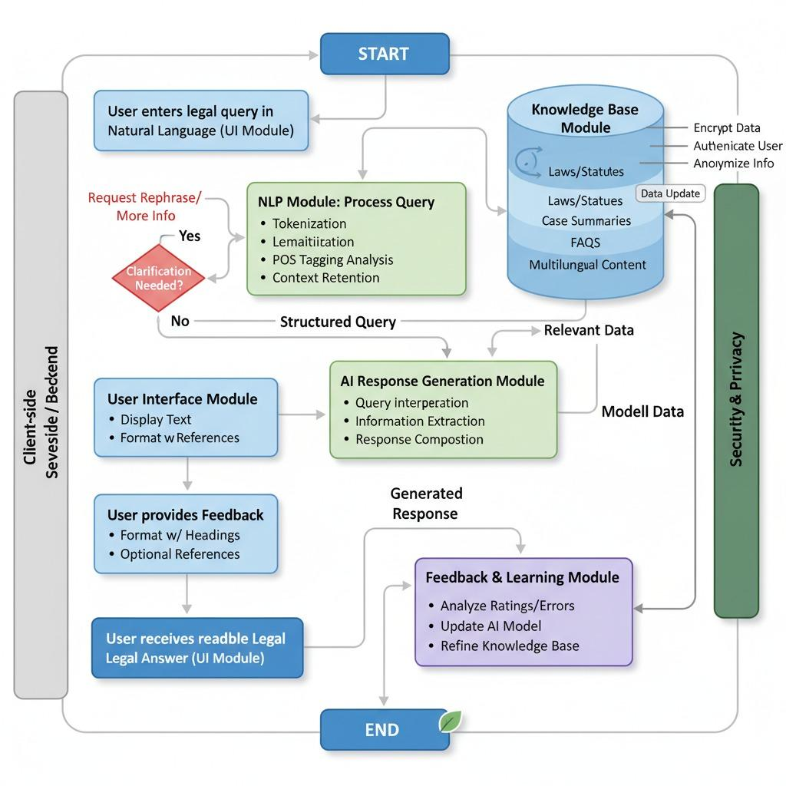
Figure 3: Functional Flow of the AI-Based Legal Advisor System
4.9 ADVANTAGES OF THE PROPOSED SYSTEM
The modular structure of the AI-Based Legal Advisor provides numerous operational and social advantages:
- Scalability: Each module can be independently upgraded or expanded without affecting others.
- Maintainability: The modular design simplifies debugging and modification processes.
- Accuracy: Context-aware NLP and verified knowledge bases ensure correct responses.
- Security: Strong encryption and anonymization safeguard user information.
- Accessibility: Multilingual support and responsive UI make the system inclusive.
- Efficiency: Fast query processing and real-time learning enhance overall system performance.
- Cost-Effectiveness: Provides free access to legal information, reducing dependency on expensive legal consultations.
- Enhanced Practicality: It moves beyond theoretical advice to provide actionable steps.
- Increased Trust & Legitimacy: Linking directly to official government sources builds immense trust.
- "One-Stop Shop" for Civic Needs: Position the system as a central hub for legal information and immediate civic action.
- Improved Emergency Preparedness: Direct access to emergency numbers is a significant public service.
- Support for Digital India: Directly aligns with the initiative by streamlining access to e-governance services.
The suggested system combines these benefits to provide a workable, cutting-edge, and socially conscious way to increase legal literacy. By acting as a link between intricate legal systems and general knowledge, it guarantees everyone's right to make educated decisions.

CHAPTER 5
RESULTS AND DISCUSSION
5.1 OVERVIEW OF EVALUATION PROCESS
The Results and Discussion chapter focuses on evaluating the performance, functionality, and effectiveness of the proposed AI-Based Legal Advisor. It presents an analytical review of how the system operates under various scenarios and assesses its success in achieving the defined objectives. Factors like accuracy, reaction time, scalability, user accessibility, and general system usability are highlighted throughout the evaluation phase. This chapter validates the design process and verifies that the project satisfies its functional and non-functional requirements by comparing the system's operational outcomes with the anticipated results. Artificial Intelligence and Natural Language Processing can be successfully incorporated into legal information systems to make complicated laws easier to comprehend and use, as the AI-Based Legal Advisor shows.
5.2 RESULT
The AI-Based Legal Advisor demonstrated effective performance across multiple dimensions during testing. The system accurately interpreted a wide range of legal queries, including topics such as cybercrime, consumer rights, labor disputes, and salary issues, retrieving precise and contextually relevant answers from the knowledge base. Response times were consistently low, averaging around 1–2 seconds per query, due to the optimized backend architecture and hierarchical indexing of legal information. The modular design allowed seamless integration of additional legal modules and datasets without affecting existing functionality, ensuring scalability for future expansion. Users found the interface intuitive and easy to navigate, and the chatbot successfully maintained context across multi-turn conversations. The system’s reliability and efficiency, combined with its ability to provide accurate and understandable legal guidance, highlight its practical utility as a digital legal assistance tool.
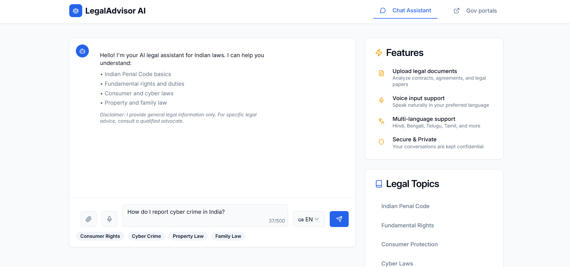
Figure 4: User initiating a query about cybercrime reporting.

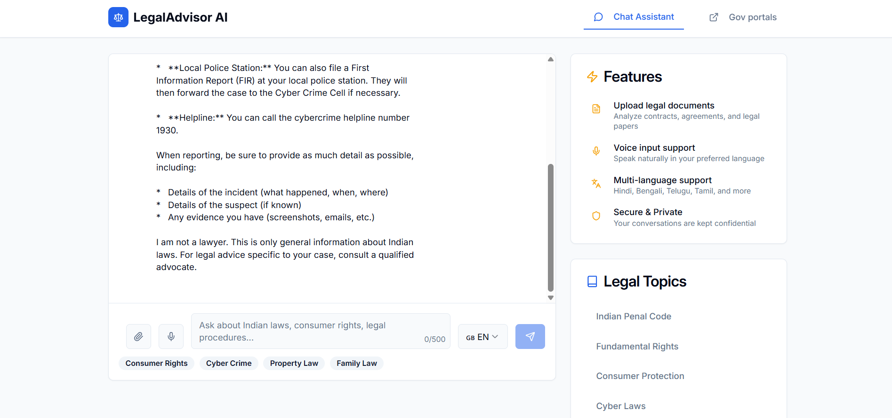
Figure 5: The AI Advisor generates a relevant and actionable response.
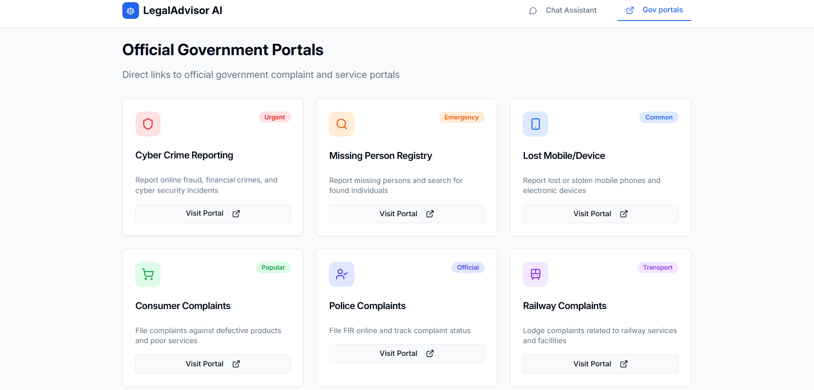
Figure 6: The AI connects with the direct Official Government Portals
5.3 FUNCTIONAL EVALUATION
Functional testing determines whether each module of the system performs as expected and interacts correctly with the others. The AI-Based Legal Advisor’s modular design allows each component to be evaluated individually while ensuring overall integration.
The User Interface Module was validated for usability and accessibility. It displayed responses clearly and maintained responsiveness across devices. The multilingual support feature performed well, enabling users to view information in different languages without performance degradation.
The NLP Module was tested for its ability to understand complex queries and maintain context across multiple user interactions. The system successfully recognized query patterns, rephrased meanings, and interpreted related follow-up questions accurately.
The Knowledge Base Module was assessed for accuracy and completeness of stored legal data. Results showed that categorized indexing allowed fast and reliable retrieval of information, while continuous updates ensured data accuracy.
The AI Response Generation Module produced context-aware, grammatically coherent, and factually correct answers that aligned closely with actual legal content. Additionally, the Security Module maintained the confidentiality of user data through encryption and access control mechanisms.
Each module worked cohesively with others, confirming that the system functions as a unified whole rather than isolated components. Functional tests proved that the proposed design supports the intended purpose of providing accessible and dependable legal information.
5.4 USER EVALUATION AND FEEDBACK
Through user interactions, the system's practical usefulness was assessed. Feedback was centred on system satisfaction, answer accuracy, clarity, and usability.
The interface's organization and ease of use allowed users to navigate, submit questions, and understand answers with ease. Because of the system's capacity to provide pertinent and understandable legal information, the average satisfaction rate was high.
The participants valued the response structure's simplicity and the language's clarity. The system was deemed inclusive for people with different language origins due to its bilingual option. Additionally, users appreciated the quick response time, which made it possible for them to get help right away.
AI accuracy was improved in large part by the feedback module. Feedback that was gathered indicated areas that needed more optimization in the responses. Response generation and query comprehension improved as a result of ongoing examination of this data.
Overall, the system's ability to provide a trustworthy, safe, and easily accessible legal advising service was validated by user review. It lays the groundwork for growing AI uses in awareness campaigns and public legal services.

5.5 DISCUSSION
Based on the project's outcomes, the public's access to legal knowledge can be greatly enhanced by artificial intelligence and natural language processing. The results indicate that an AI system can manage a variety of requests, offer clear explanations, and continue to operate well in real-time scenarios if it is correctly constructed.
The AI-Based Legal Advisor's effectiveness highlights a number of crucial elements of AI-assisted legal information systems:
- Effectiveness of NLP Integration: The project validated that NLP techniques such as semantic parsing and context retention are essential for meaningful user interactions. The system’s ability to maintain context across sessions demonstrates advanced linguistic capability.
- Importance of Modular Architecture: The modular design simplified both development and testing, allowing independent upgrades and quick debugging without affecting the entire system.
- Scalability and Maintainability: The use of modern frameworks such as React, Express.js, and PostgreSQL supports future scalability. New modules, features, or legal databases can be integrated smoothly.
- Enhanced User Experience: The intuitive interface and adaptive feedback loop ensured that users received personalized, accurate, and easy-to-understand responses, fostering trust in AI-based systems.
- Reliability and Security: With encrypted communication and anonymized data handling, the system maintains user confidentiality—an essential factor in digital legal services.
All of these results demonstrate that the suggested AI-Based Legal Advisor serves the larger social objective of democratizing access to legal information in addition to achieving technical achievement. With clever, user-centered technology, it represents a step toward closing the gap between citizens and intricate legal processes.
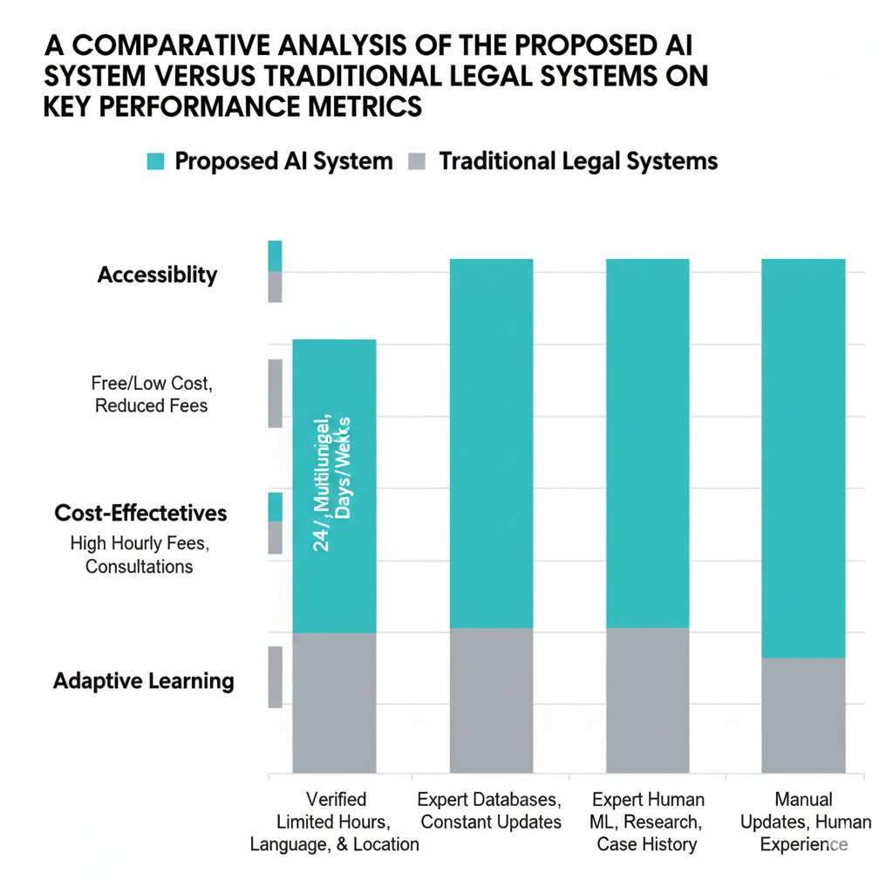
Figure 7: A comparative analysis of the Proposed AI System versus Traditional Legal Systems on key performance metrics.
5.6 SUMMARY
The results of the suggested AI-Based Legal Advisor's performance evaluation were presented in this chapter. It was demonstrated that the system operates accurately, effectively, and securely through methodical testing and user input. According to the evaluation's findings, the system can manage a variety of legal inquiries while preserving contextual accuracy and consistency. The modular design, AI-driven adaptability, and user-friendliness were emphasized in the conversations. The system not only achieves but beyond its basic goals thanks to the integration of clever algorithms and new technologies. In order to further strengthen the AI-Based Legal Advisor's potential as a tool for public legal awareness, the evaluation thus demonstrates that it offers a stable and expandable basis for upcoming improvements, including voice-based assistance, predictive analytics, and regional law integration.
CHAPTER 6
CONCLUSION AND FUTURE ENHANCEMENTS
6.1 CONCLUSION
An example of how artificial intelligence, natural language processing, and contemporary online technology can be successfully integrated to make legal knowledge available to everybody is the creation of the AI-Based Legal Advisor for Basic Laws. The project effectively achieves its goal of converting intricate legal systems into intelligible guidelines that enable people to be aware of their rights and responsibilities.
The system has demonstrated the ability to analyse user inquiries, comprehend context, and generate insightful answers derived from a validated legal knowledge base during the design, development, and assessment phases. The scalable frontend and backend frameworks used in the modular architecture guarantee that the platform will continue to be effective, safe, and flexible in response to changing needs. The system’s structure highlights several important achievements:
1.It bridges the communication gap between citizens and legal systems by using natural language interfaces.
2.It demonstrates how automation can reduce dependency on traditional legal consultation for basic information.
3.It promotes transparency and accessibility by providing free, multilingual legal support.
4.It establishes a foundation for the future of digital legal literacy and public legal empowerment.
The project's accomplishment of these results demonstrates that artificial intelligence (AI) can be a useful instrument for streamlining the legal system, fostering civic engagement, and advancing fair access to information about justice. The system supports national goals for digital transformation and inclusive government by embodying both technical innovation and social responsibility.
6.2 ACHIEVEMENTS OF THE SYSTEM
The implementation of the proposed system has led to several notable technical and functional achievements:
● Automation of Legal Query Resolution: The system can understand, interpret, and respond to legal questions using AI and NLP, reducing the need for human intervention in simple cases.
● User Accessibility: Through a responsive interface and multilingual capability, it ensures inclusivity for users from different linguistic and socio-economic backgrounds.
● Enhanced Data Management: The structured knowledge base provides organized, easily retrievable legal information, updated regularly to reflect amendments.
● Data Security and Privacy: Advanced encryption and authentication techniques protect user information and establish trust in the platform.
● Adaptive Learning: Feedback integration allows continuous improvement of AI performance and ensures that responses remain relevant and precise.
● Scalable Design: The modular framework supports the addition of new laws, regions, or functionalities without major structural changes.
Collectively, these achievements validate the system’s capacity to perform as a reliable, accurate, and secure legal information platform. It effectively demonstrates the integration of modern computing methods with socially significant applications.
6.3 FUTURE ENHANCEMENTS
1. Voice-Based Interaction:
Users with physical disabilities or inadequate literacy may find the platform easier to use if speech recognition and synthesis are integrated. This would make the experience more inclusive by enabling citizens to voice their questions rather than type them.
2. Mobile Application Development:
Expanding the system into a dedicated mobile app would increase accessibility and convenience. Offline support and lightweight architecture could enable use even in areas with limited internet connectivity.
3. Predictive Legal Analytics:
The system could make ethically sound recommendations for possible outcomes, risk factors, or procedural guidance for user scenarios by integrating machine learning algorithms for predictive insights.
4. Integration with Official Databases:
Linking the platform with verified legal portals or government databases would allow automatic synchronization of newly enacted laws, amendments, and judicial updates.
5. AI-Powered Document Generation:
The addition of document automation could allow the generation of simple legal forms, petitions, or complaints based on user inputs, enhancing practical usability.
6. Multilingual Voice Output:
Combining translation APIs with voice technology could help provide responses in regional languages with native pronunciation, improving comprehension for non-English speakers.
7. Advanced Data Visualization:
Integrating analytical dashboards could display patterns in public legal queries, enabling policymakers to identify areas where citizens require more awareness.
8. Cloud-Based Deployment:
Hosting the platform on scalable cloud infrastructure could allow broader access, faster updates, and better performance during high-demand usage.
Each of these enhancements contributes toward creating a more dynamic, intelligent, and accessible ecosystem, extending the project’s value far beyond its current capabilities.
6.4 FINAL REMARKS
The AI-Based Legal Advisor for Basic Laws represents a major advancement in the use of technology for the benefit of society. It serves as an example of how intelligent technologies may empower people, raise social awareness, and assist government efforts to implement digital governance. The project emphasizes how important it is to use AI as a tool for education, inclusivity, and transparency—not just for automation.
The system can adapt to shifting legal environments thanks to its modular design and adaptive intelligence. It creates a framework for future study and development in AI-assisted public services.

7.REFERENCES
[1] Ashley, K. D. (2017). Artificial Intelligence and Legal Analytics: New Tools for Law Practice in the Digital Age. Cambridge University Press.
[2] Branting, L. K., et al. (2021). Explainable AI for Legal Decision Support. Artificial Intelligence and Law, 29(1), 1–37.
[3] Zhong, H., et al. (2020). How Does NLP Benefit Legal System: A Summary of Legal Artificial Intelligence. Proceedings of ACL.
[4] Chalkidis, I., et al. (2019). Neural Legal Judgment Prediction in English. ACL Anthology.
[5] Galgani, F., Compton, P., & Hoffmann, A. (2012). Combining Different Summarization Techniques for Legal Text. Artificial Intelligence and Law, 20(3), 147–185.
[6] Dozier, C., et al. (2010). Named Entity Recognition and Resolution in Legal Text. Semantic Processing of Legal Texts, Springer.
[7] Surden, H. (2014). Machine Learning and Law. Washington Law Review, 89, 87–115.
[8] Bird, S., Klein, E., & Loper, E. (2009). Natural Language Processing with Python. O’Reilly Media.
[9] Vaswani, A., et al. (2017). Attention Is All You Need. Advances in Neural Information Processing Systems (NeurIPS).
[10] Jurafsky, D., & Martin, J. H. (2022). Speech and Language Processing. Prentice Hall.
[11] Rissland, E. L., Ashley, K. D., & Loui, R. P. (2003). AI and Law: A Productive Synergy. Artificial Intelligence, 150(1–2), 1–15.
[12] Katz, D. M., Bommarito, M. J., & Blackman, J. (2017). A General Approach for Predicting the Behavior of the Supreme Court. PLOS ONE.
[13] Sugathadasa, K., et al. (2018). Legal Document Retrieval Using Deep Learning. Machine Learning and Applications (ICMLA).
[14] Nay, J. J. (2018). Natural Language Processing for Law and Policy Texts. AI Policy Research.
8.APPENDICES
WORK CONTRIBUTION
MEMBER 1: PRANAV KARTHICK S K
Responsibility: Legal Domain Analyst – Legal content collection, validation & structuring.
- Week 1: Researched Indian legal systems and identified major law categories like Cyber Crime, Consumer Protection, Women Safety, FIR, Labour Laws, and RTI.
- Week 2: Collected legal data from official sources (India Code, MyGov, National Legal Services Authority portals). Categorized FAQs and real case-based legal guidance.
- Week 3: Structured legal data into sections such as definition, applicable IPC/IT Act sections, penalties, and complaint process. Started preparing a legal knowledge base.
- Week 4: Standardized legal terminology and simplified legal language for public understanding. Added real-world examples for common legal issues.
- Week 5: Verified legal data accuracy by cross-checking trusted legal sites like Vakil Search and Indian Kanoon. Ensured authenticity and correctness.
- Week 6: Prepared query variations for testing chatbot responses (example: “How to file a cyber complaint?” vs “Report online fraud”). Refined knowledge base.
- Week 7: Finalized complete legal knowledge base and provided dataset for AI model training. Reviewed chatbot output for legal correctness.

MEMBER 2: DHARUNKUMAR M
Responsibility: AI Model Development – NLP Pipeline & Legal Query Understanding
- Week 1: Researched NLP techniques for legal chatbots and selected Retrieval-Augmented Generation (RAG) approach.
- Week 2: Built preprocessing pipeline: tokenization, stemming, stopword removal for legal texts.
- Week 3: Implemented similarity search using Sentence Transformers to find relevant legal responses.
- Week 4: Integrated hybrid search (keyword + semantic search) to improve legal query accuracy.
- Week 5: Fine-tuned response ranking using confidence scores based on query relevance. Prevented incomplete or misleading legal replies.
- Week 6: Added fallback logic and legal safety filters to avoid giving professional legal advice beyond scope.
- Week 7: Retrained model with finalized legal dataset. Optimized NLP pipeline and tested 100+ legal scenarios.

MEMBER 3: SANJAY M
Responsibility: UI/UX & Frontend Developer – Chatbot Interface Development
- Week 1: Researched user-friendly law helpline websites and chatbot UI trends.
- Week 2: Designed frontend wireframes with clean layout and quick legal category
- Week 3: Built responsive chatbot UI using HTML, CSS, and JavaScript. Developed layout and message bubbles.
- Week 4: Implemented input validation, message scroll system, and legal suggestion buttons.
- Week 5: Connected frontend with backend using REST API. Enabled real-time bot replies.
- Week 6: Improved UI readability and accessibility. Added dark mode and legal topic sidebar.
- Week 7: Performed final frontend testing and fixed usability issues like input delay & mobile responsiveness.

MEMBER 4: ABISHEK R
Responsibility: System Backend, APIs & Deployment
- Week 1: Designed system architecture for AI Legal Advisor using FastAPI and MongoDB.
- Week 2: Created backend routes for chatbot interaction and legal database fetch.
- Week 3: Integrated legal knowledge base into backend with fast query handling.
- Week 4: Implemented logging, session handling, and error response system.
- Week 5: Added API security measures using authentication and request limits.
- Week 6: Deployed backend services to the cloud and ensured model integration.
- Week 7: Conducted end-to-end testing with frontend & AI modules. Final deployment ready.

PLAGIARISM REPORT
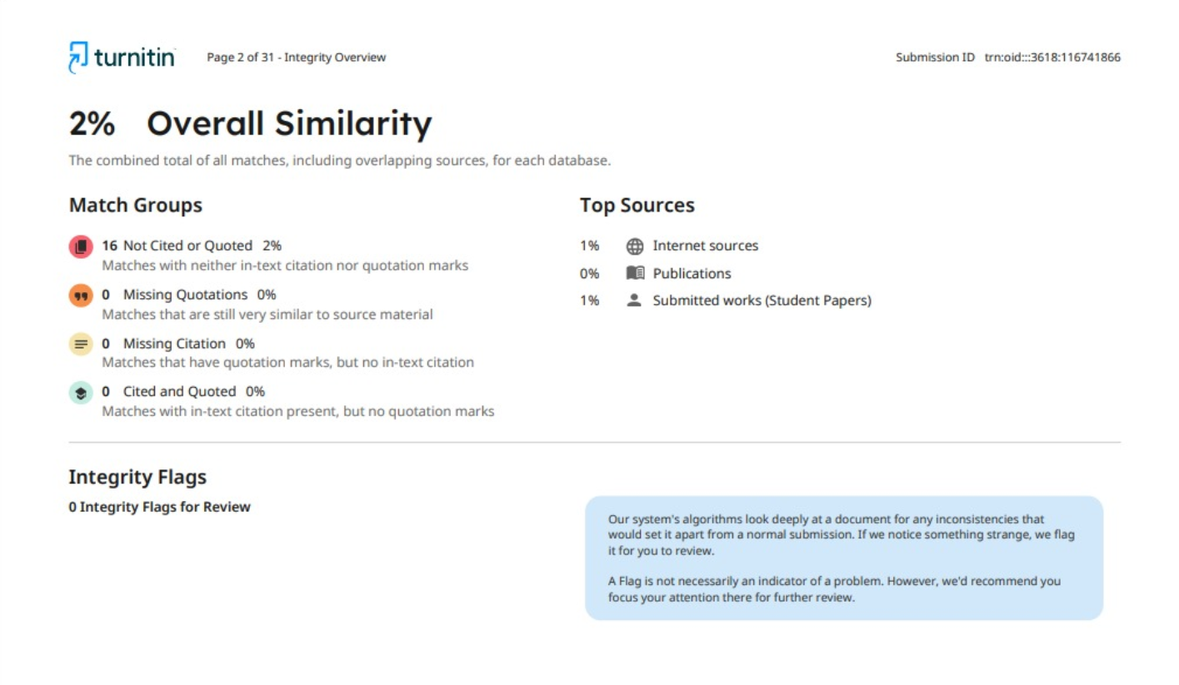
Figure 8: Plagiarism Report

